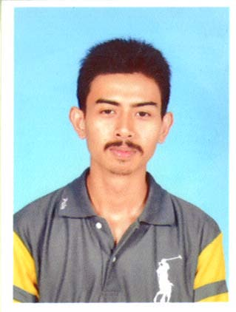

Muhammad Aiyuub bin Ahmad Ragib
890401-14-5137
No.21, Jalan Bunga Kemboja 7c,
Taman Muda, 56100,
Ampang, Kuala Lumpur

Telephone number : 017-2595606
E-mail address : aiyuub_ampang3@yahoo.com

PERSONAL PARTICULAR :

Date of birth : 1 April 1989.
Place of birth : Hospital Kuala Lumpur.
Marital status : Single.
Nationality : Malaysian.

EDUCATION :

• October 2012 – January 2017
Bachelor in Mechanical Engineering (Hons.) from Universiti Tenaga Nasional (UNITEN)
(Obtained CGPA score at 2.34)

• July 2010 – May 2011
Diploma in Mechanical Engineering from Politeknik Merlimau Melaka.
(Obtained CGPA score at 2.79)

• July 2007 – July 2009
Certificate in Mechanical Engineering from Politeknik Shah Alam.
(Obtained CGPA score at 2.99)

• 2000 – 2005
Sekolah Menengah Kebangsaan Dato’ Ahmad Razali.

EXTRA-CURRICULAR ACTIVITIES :

• 2003 – 2005
President of the Geographic Club of Sekolah Menengah Kebangsaan Dato’ Ahmad
Razali.

• 2000 – 2002
Member of the Badminton Club of Sekolah Menengah Kebangsaan Dato’ Ahmad
Razali.

WORK EXPERIENCE :

• March 2016 – June 2016
Internship at GLOBE ENGINEERING SDN BHD, Jalan Klang Lama
Position : Project Engineer
Exposure gained :
-Designing fire alarm system.
-Trouble-shooting in fire alarm system at construction site.
-Supervised worker when installing and testing the fire alarm system at construction site.

• March 2009 – June 2010
Working at RS SPEEDY, Taman Tasik Ampang
Position : Chief mechanic.
Exposure gained :
-Maintaining customer’s motorcycle.
-Trouble-shooting motorcycle problem.
-Supervised other mechanic.

• July 2008 – December 2008
Internship at NAZA KIA SERVICES, Selayang
Position : Mechanic
Exposure gained :
-Maintaining customer’s vehicle.
-Trouble-shooting vehicle problem.
-Gained knowledge in mechanical movement and principal.

SKILL/STRENGHTS :

• Can work under pressure and meet tight deadlines.
• Speak fluent Bahasa Malaysia and English.
• Fluent in written Bahasa Malaysia and English.
• Independent and self-motivated.
• Can work in group or be a team leader.
• Proficient in using Microsoft Word, Point and Excel.
• Proficient in using Autocad, Autodesk and Solidwork.
• Clean driving license (B&D).

OTHER INFORMATION :

• Obtained boiler course certificate.
• Obtained Autodesk course certificate.
• Have the skills to used arc, gas, MIG and TIG welding.
• Have the skills to maintain and repair mechanical equipment or apparatus.

REFERENCES :

The following person have agree to provide any additional information regarding my qualifications and character :

• Mr. Nik Mohammad
Project Manager of Globe Engineering Sdn Bhd
Telephone number : 019-3998456

• Mr. Mohamad Widad bin Ahmad ragib
Senior Regional Manager of Naza Kia
Telephone number : 013-3636073

• Mrs. Norhapizah binti Abdullah
P.A. (Pensyarah Akademik) Politeknik Merlimau Melaka
Telephone number : 019-7363675

